Margarita Chicken Quesadillas
Prep time 20 min Cook time 10 min
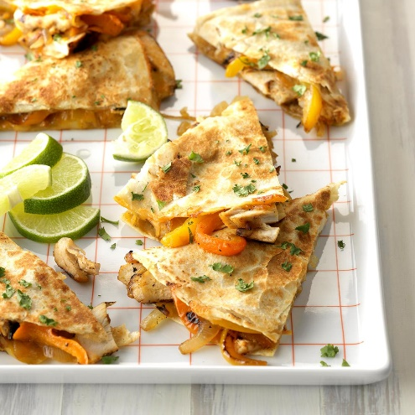
Ingredients
2 boneless skinless chicken breasts
¾ cup thawed frozen limeade concentrate
1 large onion, diced
1 medium sweet orange pepper, diced
1 medium sweet yellow pepper, diced
1 tablespoon canola oil
¼ teaspoon salt
¼ teaspoon pepper
4 flour tortillas (10 inches)
1 cup shredded Monterey Jack cheese
1 cup shredded cheddar cheese
2 tbsp butter, melted
1 tbsp lime juice
1 tbsp chopped fresh cilantro
Lime wedges, optional
Directions
- Place chicken in a large Ziploc bag. Add limeade concentrate and toss to coat. Refrigerate for 6 hours or overnight.
- In a large nonstick skillet, sauté the onion and sweet peppers in oil until tender. Season with salt and pepper. Remove and set aside. Wipe out skillet.
- Drain chicken and discard marinade. Cook chicken in a large skillet. Cut chicken into ¼ inch strips or shred. Set aside.
- On one tortilla, layer Monterey Jack cheese, chicken, pepper mixture and cheddar cheese. Cover with a second tortilla. Combine butter and lime juice, then brush over tortillas.
- In same skillet used to cook vegetables, cook quesadillas over medium heat until cheese is melted, 2 to 3 minutes per side. Keep warm in oven while cooking remaining quesadillas.
- Cut each quesadilla into 4 wedges. Sprinkle with cilantro. Serve with lime wedges if desired.
Notes
You can substitute 2 cups of Mexican cheese for cheddar and Monterey Jack.

